Prophetess Dr. Joyce M. Hogan
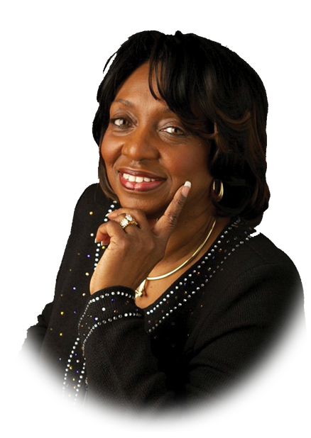
Serving alongside her husband, Apostle Kenneth D. Hogan, as senior pastors of Living Bread Church, Prophetess Joyce is known for her powerful prayers of intercession, her accurate words of prophecy and her humble spirit. She also has a strong anointing as a seer. God has given her awesome visions that have not only broken chains in her life, but the lives of many others.
The power of prayer has been evident in her life for many years. As the only child of George and Maria Vasser, who were Pastors and Intercessory Prayer Leaders at Living Bread Church, she was exposed at an early age to the fruits of intercession. She exhibits a powerful anointing to minister the Word of the Lord and to usher in His presence.
Prophetess Joyce also has a heart for the nurturing and encouragement of godly women. As pastor of the women’s ministry at Living Bread Church, “Cornerstone Women,” she ensures that women are given instruction, encouragement and fellowship for their daily lives. She does this not only by providing guest speakers and bi-monthly forums, but also by serving as a true, living model of a “Cornerstone Woman.” Because of her desire to see women walk in their kingdom destiny, she established a women’s touch group with Living Bread Church that is made up of women that function as an extension of her to help encourage and develop the women of Living Bread Church.
Prophetess Joyce was ordained to the office of a Prophetess alongside her husband on March 21, 1999, under the headship of Apostle John Eckhardt. She holds a Bachelor’s degree in Theology from Christian International and a Master’s degree in Pastoral Counseling from Destiny School of Ministry.
Prophetess Joyce received an honorary doctorate degree on September 26, 2010 from Bethel Christian University.
Prophetess Joyce and her husband of 41 years, Apostle Kenneth D. Hogan, together have one daughter and son-in-law, Prophetess Kenya and Elder Brian Johnson, one son and daughter-in-law, Daimeon and Tara Hogan; two grandsons, Brandon and Brian Johnson II and one granddaughter Jocelyn Shamaya.

